Statement of Work
(SOW)

for the

Unmanned
Control & Tracking System
(UCATS)

DJ³K Team

Kurt Chewning
Jennifer Greene
Dave Manley
Jeanette Smith
John Smith

Sponsors: Dr. Kuo-Chu Chang
&
Ashwin Samant
Department of Systems Engineering & Operations Research
SYST 798 Applied Projects Course
Fall 2009
TABLE OF CONTENTS

1.0 INTRODUCTION 3
2.0 BACKGROUND 3
3.0 SCOPE OF EFFORT 5
4.0 LOCATION OF WORK 6
5.0 APPLICABLE DOCUMENTS 6
5.1 Reference Documents 6
5.2 Informational Documents 6
6.0 TASKS 6
6.1 Project Proposal 6
6.2 Deliverables 7
APPENDICES 8
APPENDIX A: Proposal 9

1.0 INTRODUCTION
This Statement Of Work (SOW) identifies the tasks for the design and development of a Unmanned Control and Tracking System (UCATS) prototype to be done by DJ³K team. Dr. K.C. Chang and Ashwin Samant, from George Mason University (GMU), require the UCATS as a communication, control, and tracking system to facilitate and increase the efficiency of the manpower needed to carry out a successful autonomous Unmanned Aerial Vehicle System (UAVs) surveillance mission. These stakeholders specifically need the decision support that will enable an operator to control a group of UAVs from a remote location.

2.0 BACKGROUND
Currently there are many challenges in the deployment of UAVs. One of the challenges is the need to minimize the amount of operators required to control and coordinate UAVs, by incorporating autonomous control of UAVs. See Figure 1. That need is expressed by Zachary, a Captain of the United States Air Force in the following statement:

“ Secretary of Defense Robert M. Gates described the appetite for UAV-provided real-time imagery as “insatiable.” To meet this demand, 52 of the 93 aircraft purchased by the United States Air Force in 2009 will be unmanned. This increases the stress put on the pilot and sensor operator training pipelines. The service will require 1,100 crews by 2012 to meet its goal of 50 orbits. Currently, only 474 forces are trained. The current approach is to increase its training pipeline from 160 crews annually to 360 annually by 2012. One solution to this problem is to relax the one pilot dependency by incorporating autonomous control behaviors into our fleet. By allowing the UAVs to handle low-level details such as navigation, a single human controller could monitor several UAVs simultaneously.”

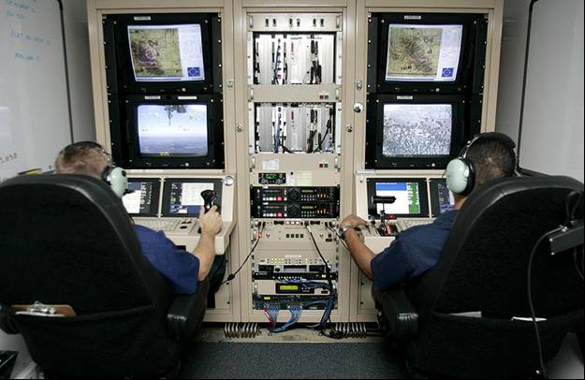
Figure 1: Air and Marine officers control and watch images taken by UAVs during surveillance missions concerning illegal activities to Border Patrol agents from a remote location.

Dr. K.C. Chang, GMU professor of Systems Engineering and Operations Research, and Ashwin Samant, a GMU PhD student who developed the tracking software and initial Graphical User Interface (GUI), have already put in place an algorithm that tracks the target which the UAV team will employ. This GUI uses Google Maps and Google Earth API, Matlab, and Eclipse IDE for JavaScript and HTML. The tracking algorithm estimates the waypoints followed by the UAV based on the motion and heading of the target. The tracking algorithm uses Tangent-Plus-Lyapunov vector field guidance, and this software was developed originally for a single UAV. This algorithm does take into account obstacle avoidance with a simple model. However, it has not been integrated into the GUI. The GUI utilizes the 2D and 3D capability of Google Earth and Google Maps and the ability to view different angles and altitudes, enabling the operator to track and monitor targets in an urban environment. Figure 2 illustrates the current GUI design.

This system can be used by the Air Force Office of Scientific Research, Department of Defense, Border Patrol, Drug Enforcement Administration, Federal Bureau of Investigation, Central Intelligence Agency, as well as for search and rescue missions.

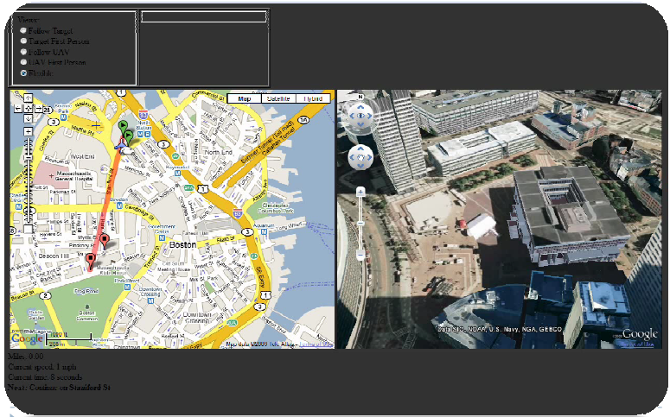
Figure 2: Current GUI design allows single UAV tracking.

3.0 SCOPE OF EFFORT
The effort defined in this SOW will be done by a 5 person-semester effort. The timeframe of the work is from August 31 to December 18, 2009. The work is to be done by the DJ³K, composed of five team members of the GMU Systems Engineering Masters program, and with the assistance of GMU Systems Engineering and Operation Research PhD student Ashwin Samant as a technical consultant.

Currently the system lacks formal systems engineering documentation. This team will provide documentation of the deliverables listed in Table 1 (pp.7). The software developed for single UAVs will be expanded for multiple UAVs to collaboratively track multiple targets. The stakeholders expressed the need for the prototype GUI to be improved to incorporate a communication component. This component will include a ground Command and Control (C2) center that will effectively communicate to the UAVs conducting the mission. The goal is to autonomously control a group of UAVs from a remote location for surveillance and tracking operations in an urban environment.

Intel will provide the target’s initial and likely destination location and the team of UAVs will track the target. The content and the mechanism of the communication between the UAV and the C2 center will be determined during the semester. The development of the control and communication part of the algorithm is the key interest to the primary stakeholder: K.C. Chang. An integral part for the autonomous control of UAVs is the assignment and prioritizing of UAVs. The communication and tracking algorithm must assign UAVs to execute a mission without the intervention of a pilot to maintain in-air formations, surveillance of an area, and to assign UAV flying patterns while they are looking for targets.

4.0 LOCATION OF WORK
The work stated in this SOW will be performed at the Naval Surface Warfare Center, Dahlgren, and at GMU, Fairfax Campus. The DJ³K team will visit GMU during the semester as needed. Phone conferences and email will also be modes of communication. Information exchange will occur through DJ³K’s website (http://mason.gmu.edu/~jgreene7/ ) and emailing and deliverables will be made through (https://gmu.blackboard.com/ ).

5.0 APPLICABLE DOCUMENTS
The following documents helped in the development of the SOW. These are available in electronic format if needed.

5.1 Reference Documents
- Unmanned Control & Tracking System (UCATS) proposal presentation (Appendix A)
- Unmanned Control & Tracking System (UCATS) proposal

5.2 Informational Documents
- Tracking with UAV Using Tangent-Plus-Lyapunov Vector Field Guidance paper and presentation
- A UAV- Target Tracking Scenario Using Google API and Matlab
- Executive Decision Support: Single-Agent Control of Multiple UAVs
- Airspace Management of Autonomous UAVs
- No Pilots, No Problem: Autonomous Control Next Logical Step for UAVs

6.0 TASKS
DJ³K team will be working in collaboration with Ashwin Samant for the following tasks:

6.1 Project Proposal
Proposal document and proposal brief presented to Dr. Speller, Ashwin Samant and Dr. K.C. Chang for approval of Capstone Applied Project Course. The schedule of the project is also included in the proposal brief.

6.2 Deliverables
The following deliverables will be provided to Dr. Speller, Ashwin Samant and Dr. K.C. Chang as well as to the faculty for review through the DJ³K team website (http://mason.gmu.edu/~jgreene7/ ) and to GMU blackboard (https://gmu.blackboard.com/). Ashwin Samant and the DJ³K team will work together to deliver an improved prototype GUI.

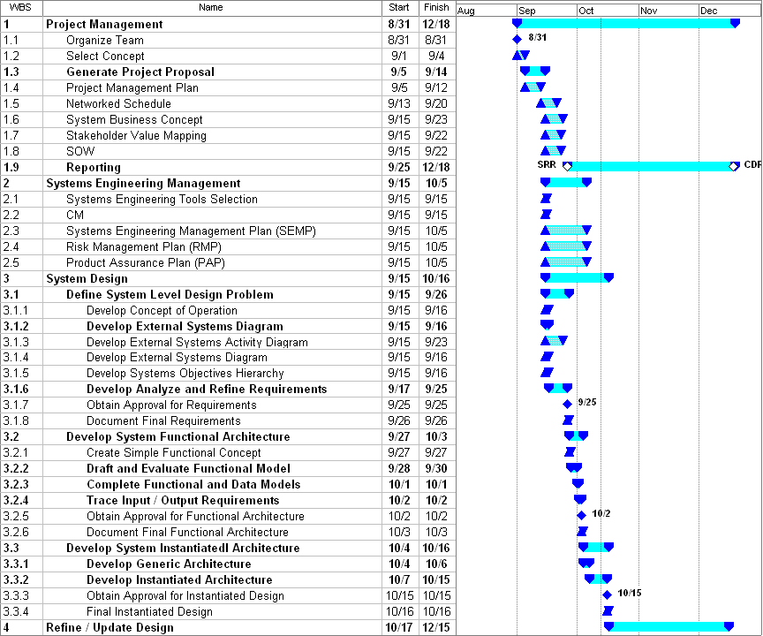
Figure 3: UCATS WBS

APPENDICES

APPENDIX A: Proposal
- Unmanned Control & Tracking System (UCATS) proposal presentation

Zachary C. Gray, Captain, USAF; Gilbert L Peterson, PhD USAF; “No Pilots, No Problem: Autonomous Control Next Logical Step for UAVs”. pp 1-2.
http://en.wikipedia.org/wiki/Unmanned_aerial_vehicle
Chang, K.C.; Chen, Hongda; Agate, C.S.; “Tracking with UAV Using Tangent-Plus-Lyapunov Vector Field Guidance” , George Masson University and Toyon Research Corporation ,12th International Conference on Information Fusion Seattle, WA, USA, July 6-9, 2009, pp 1-10.
Ding, Xu Chu; Powers, Matthew; Egerstedt, Magnus; Young, Shih-Yih; Balch, Tucker ; “Executive Decision Support: Single-Agent Control of Multiple UAVs”, IEEE Robotics & Automation Magazine, June 2009, pp.73-81.
Yadgar, Osher; Vincent, Regis; “Airspace management of Autonomous UAVs”, SRI International.
Zachary C. Gray, Captain, USAF; Gilbert L Peterson, PhD USAF; “No Pilots, No Problem: Autonomous Control Next Logical Step for UAVs”. pp 1-2.

